Tutorials
Beginners Guides
- Choose a theme and domain
- Intro to the Elements
- Choose a Page Layout
- Create more pages for Your site
- Adding Pictures to your site
- Uploading Pictures to your Site
- Edit the Header
- Edit Fonts
- How to Switch Themes
- Start a Blog
- Alter Header Types
- Publish Your site

Text and Images
13. Add and Edit text
14. Change Fonts
15. Upload and Image
16. Create Text links
17. Create Image Links
18. Create Button Links
19. Create Anchor Links
20. Upload PDF’s, PowerPoint Slides and other Docs
21. Upload an Image Slideshow
22. Upload and Image Gallery
23. Upload a Logo to Your Site
Pages and Navigation
24. Copy a Page
25. Reorder Pages
26. Organize Subpages

Video and Audio
25. Embed Videos from YouTube
26. Embed Videos from Vimeo and Other Hosts
27. Upload Music using Weebly Audio Player

Editable Widgets and More
28. Add a Calendar to your site
29. Add Your Twitter to your site
30. Add a widget, videos, or other content by embedding code

Extra Help
(Beginners Guide Video) 1:04.32
Teacher Webpages
- Use Mozilla Firefox. It can work in Google Chrome, as well, but Firefox is encouraged for now.
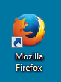

- Go to http://education.weebly.com, not the regular Weebly page.

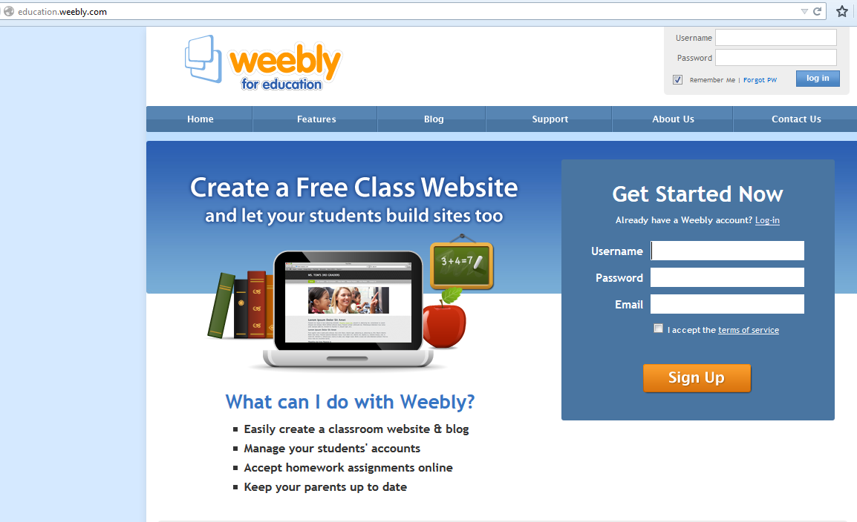

- Sign up for a free account, or log into your account using your email and your password you created.
- Click on the Add Site button to create a new website. If you have an existing website, click the Edit button.
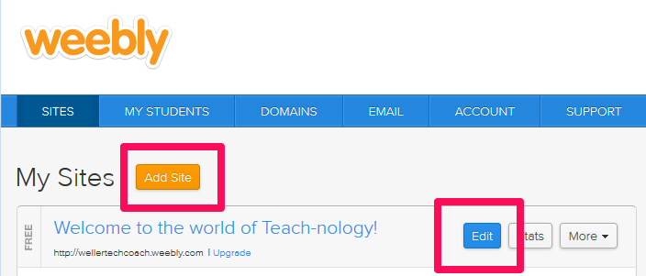

- Make sure you choose Site for your focus.

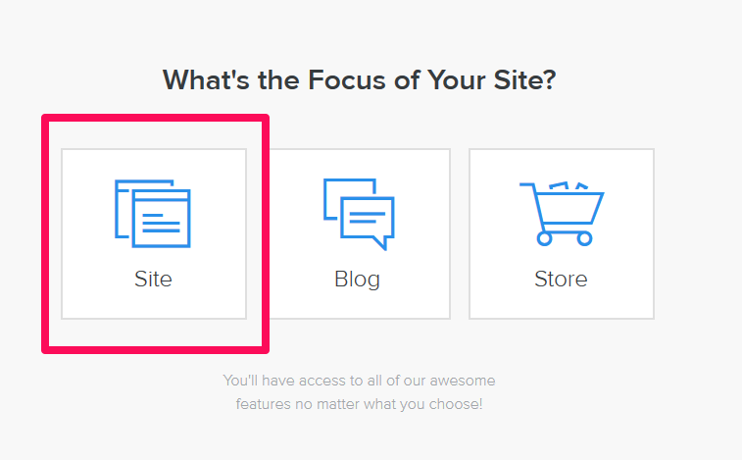

- Choose a theme by hovering over the one you want, and selecting Choose in the lower right corner of the image.

- Choose a web address (subdomain) for your site. It will be hosted by Weebly (and thus have a .weebly.com end to it unless you choose to pay for your own domain name.

